4. Design Zero-shot, One-shot, and Few-shot Prompts to Generate a Professional Email Requesting Leave Due to Illness
A. Zero-shot Prompt
Write a professional email to a college professor requesting two days of leave due to illness. Include a suitable subject, polite greeting, reason for leave, dates as placeholders, a request for approval, and a professional closing. Use correct grammar and formal language.
Expected Output:
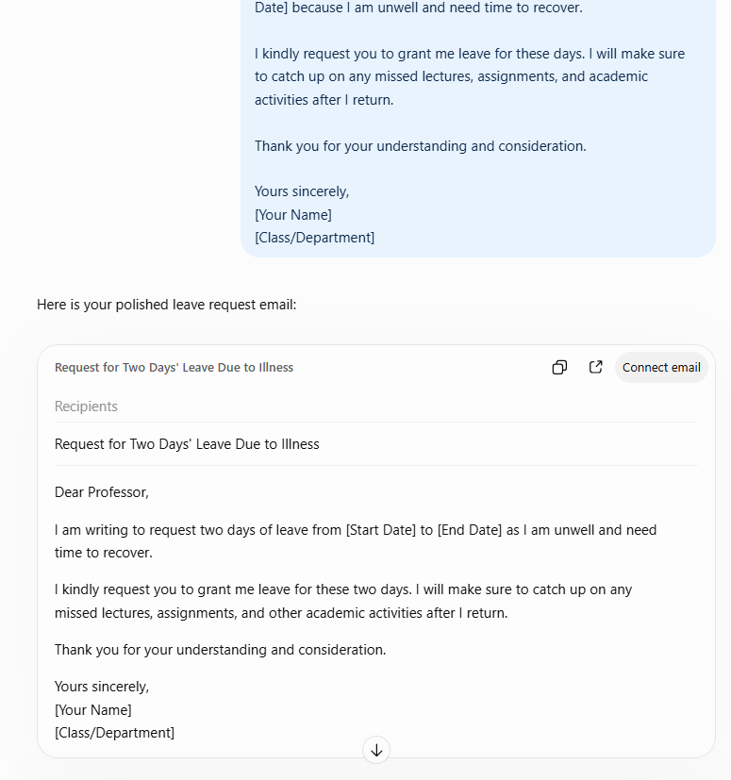
B. One-shot Prompt
Example:
Subject: Request for Permission to Attend an Event
Dear Sir,
I am writing to request permission to attend an important academic event on [Date]. I will ensure that I complete any pending academic work.
Thank you for your consideration.
Yours sincerely,
[Your Name]
Now write a professional email requesting two days of leave due to illness. Include a subject, greeting, reason, leave dates, request for approval, and closing. Follow the example's format.
Expected Output:
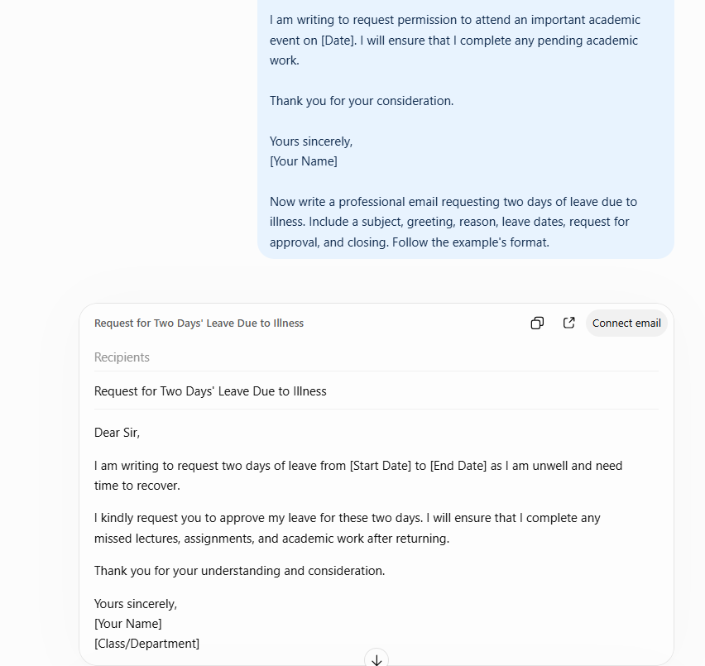
A formal email with a subject line, respectful greeting, clear illness-related reason, two-day leave request, and professional closing.
C. Few-shot Prompt
Example 1:
Subject: Request for Assignment Extension
Dear Professor,
I kindly request an extension for submitting my assignment due to unexpected circumstances. I will submit it by [New Date].
Thank you for your understanding.
Yours sincerely,
[Your Name]
Example 2:
Subject: Request for One-Day Leave
Dear Sir/Madam,
I am writing to request one day of leave on [Date] due to a personal commitment. I will complete any missed work promptly.
Thank you for considering my request.
Yours sincerely,
[Your Name]
Now write a professional email requesting two days of leave due to illness. Include the subject, greeting, reason, dates, request for approval, plan to catch up on missed work, and closing. Maintain a polite and formal tone.
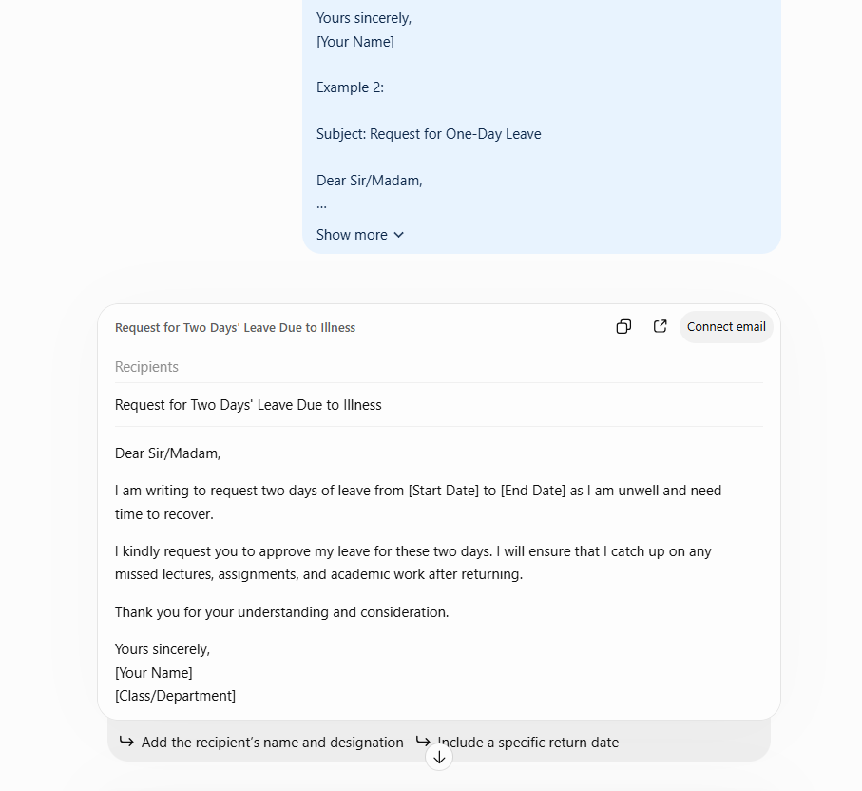
D. Comparison of Generated Emails
Criterion | Zero-shot | One-shot | Few-shot
Tone | Depends on instructions | Follows one formal example | Learns from multiple formal examples
Grammar | Should be checked | May follow demonstrated phrasing | May show more consistent phrasing
Formatting | Based on instructions | Follows one structure | Can follow a consistent structure
Completeness | Depends on requested details | Guided by one example | Multiple examples guide structure
Result: All three techniques can generate professional leave-request emails. One-shot and few-shot prompts provide formatting examples, while clear instructions help ensure the email contains all required details.

